**PROJECT REPORT TEMPLATE**

**VEHICLE MANAGEMENT SYSTEM USING FOR SALESFORCE**

**1. INTRODUCTION**

**1.1 Overview**

A vehicle management system is a software system — or platform — that serves to manage commercial fleets of vehicles, such as cars, vans or trucks — or even heavy equipment — to ensure they’re utilized safely, efficiently and professionally, while making sure they’re well maintained and high-performing.

Vehicle Management is an application where a customer Details are stored in order to choose cars, bikes and commercial vehicles for travel with in the city. The data which is stored here is further used to remind them if any offers are provided during the seasons and any updates regarding vehicles are sent to them in the form of messages and mails.

**1.2 Purpose**

Competition is at its prime in nearly all industries and all trades. Businesses, worldwide, are striving to achieve high performance and efficiency, yielding results that will keep them viable and at a nominally competitive growth rate. For instance, transportation of people, goods and services are typically complemented with one or more types of fleets of vehicles. If managed incorrectly, vehicles and equipment — and drivers, for that matter — may become liabilities. In short, that’s where a vehicle management system comes in.

Technologies such as Telematics are available to mitigate the risk of that outcome becoming a reality. Fleet management systems are now readily available, using such technologies, to help businesses strategize their operations and coordinate the use of assets and workforce, toward optimal performance and efficiency. Thus, improving their viability and growth.

**2 PROBLEM DEFINITION AND DESIGN THINKING**

**2.1. Empathy Map**

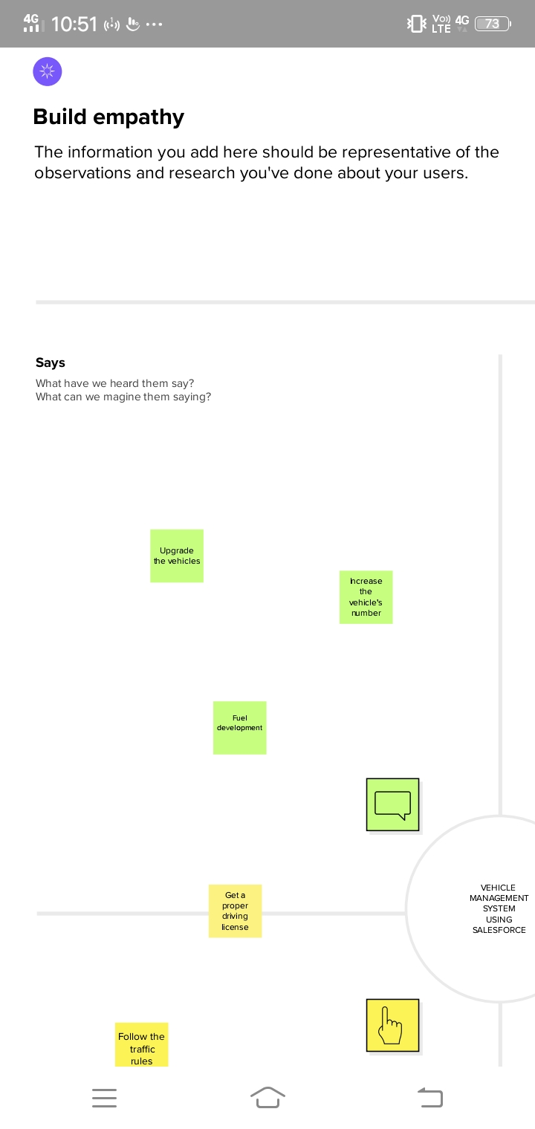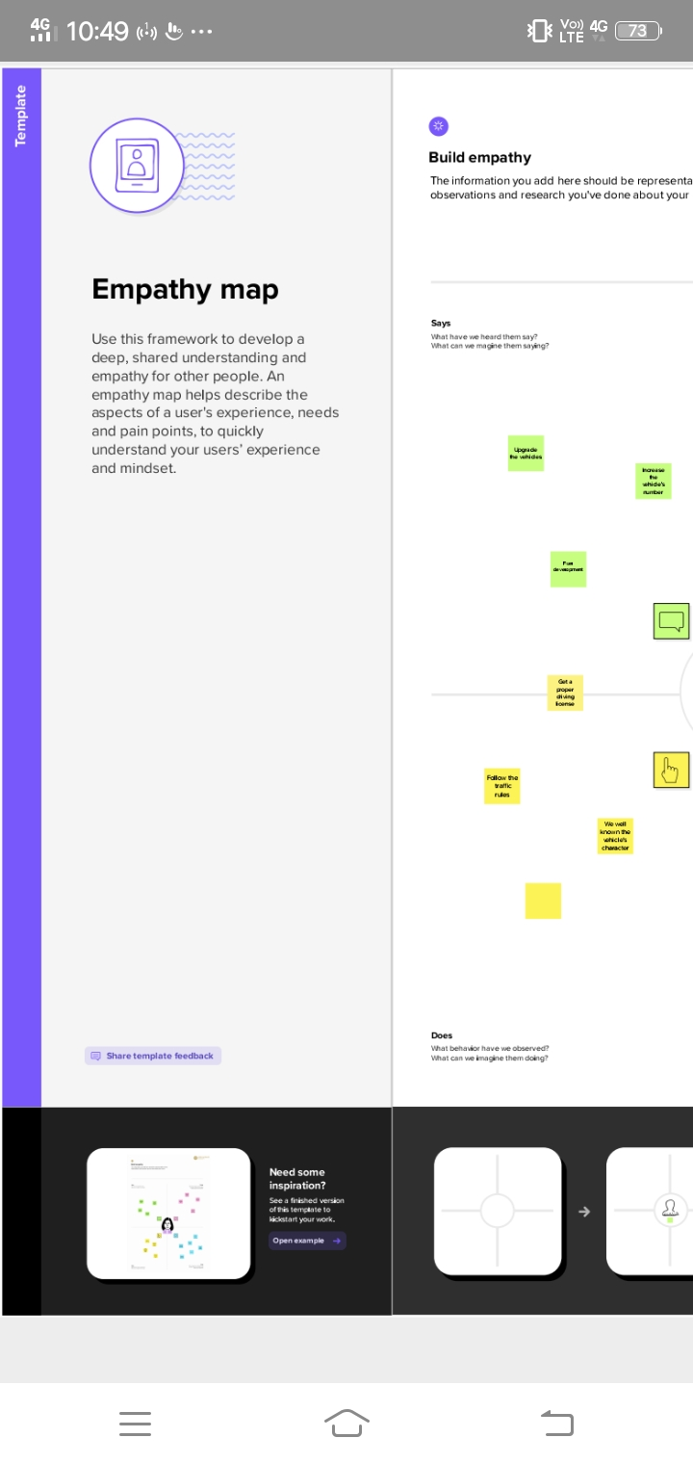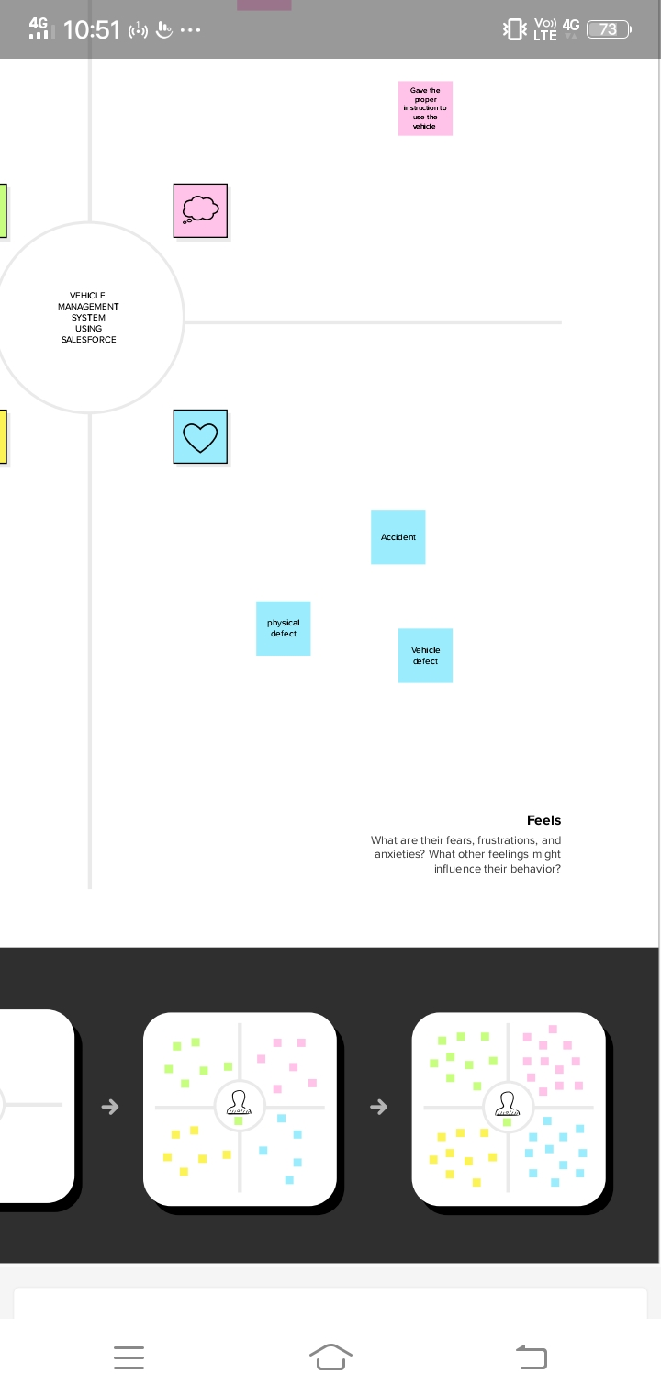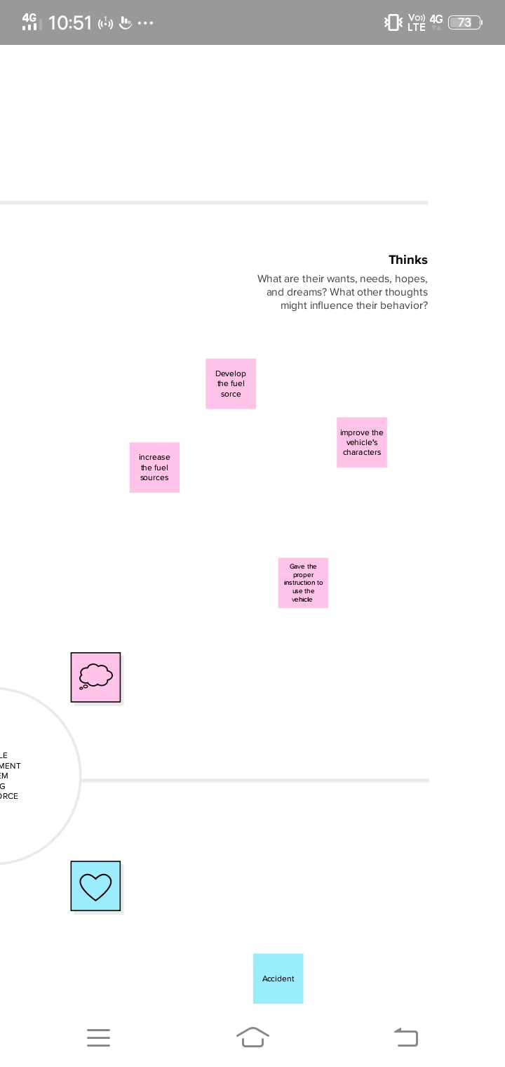

**2.1 Ideation and Brainstorming Map**

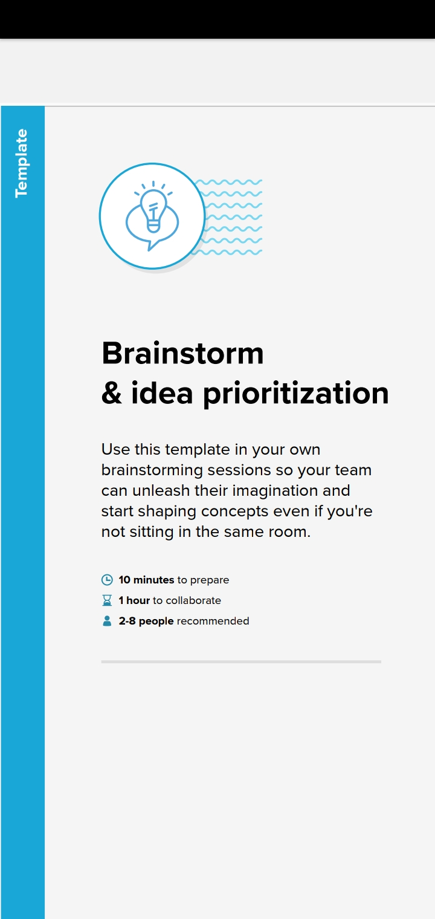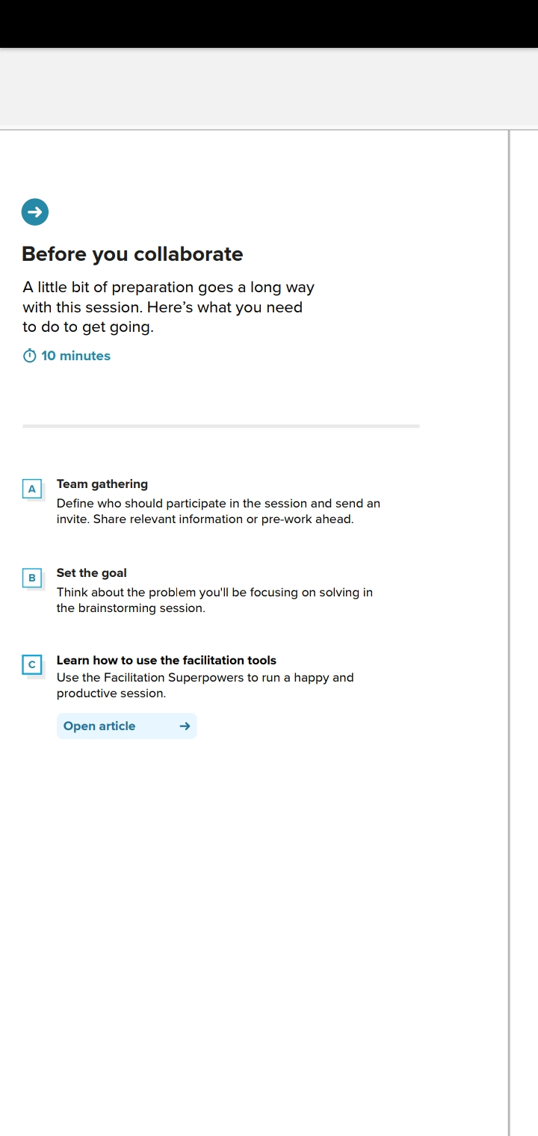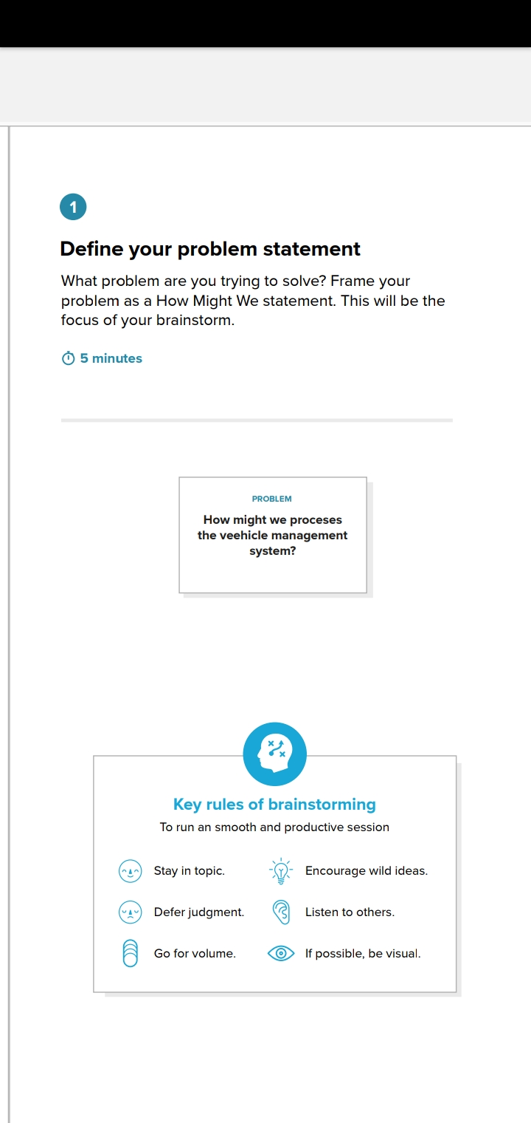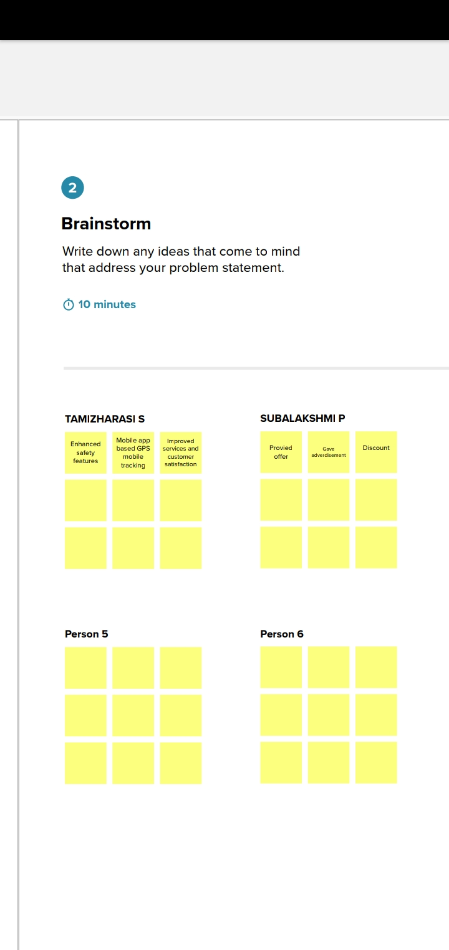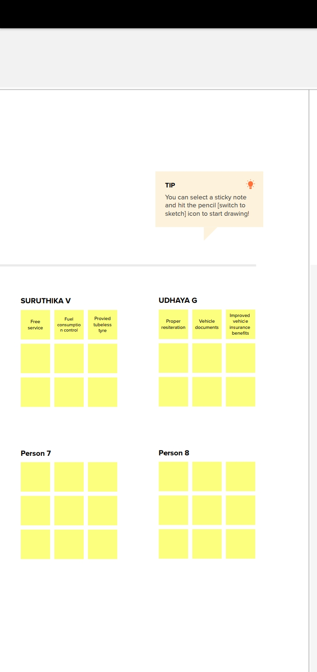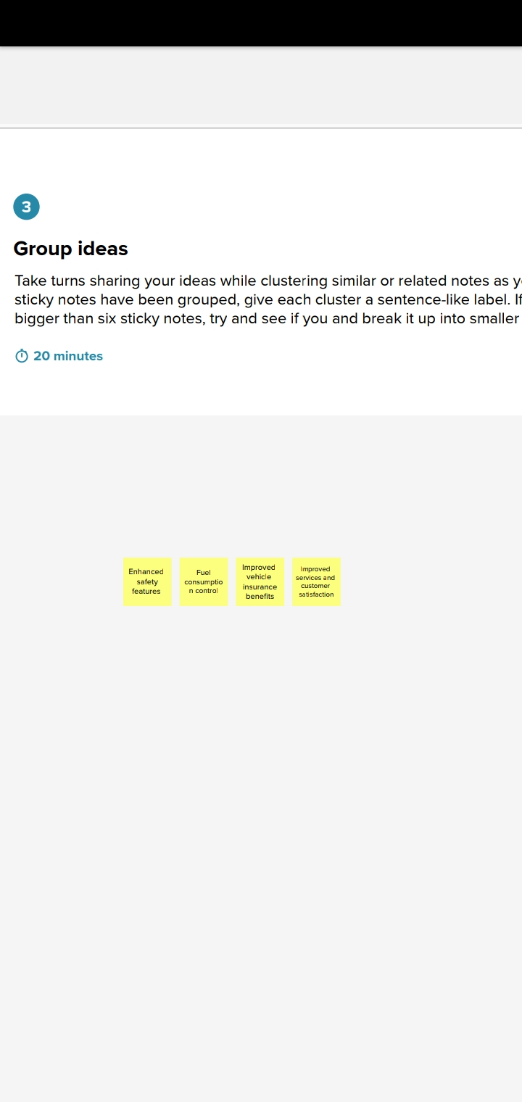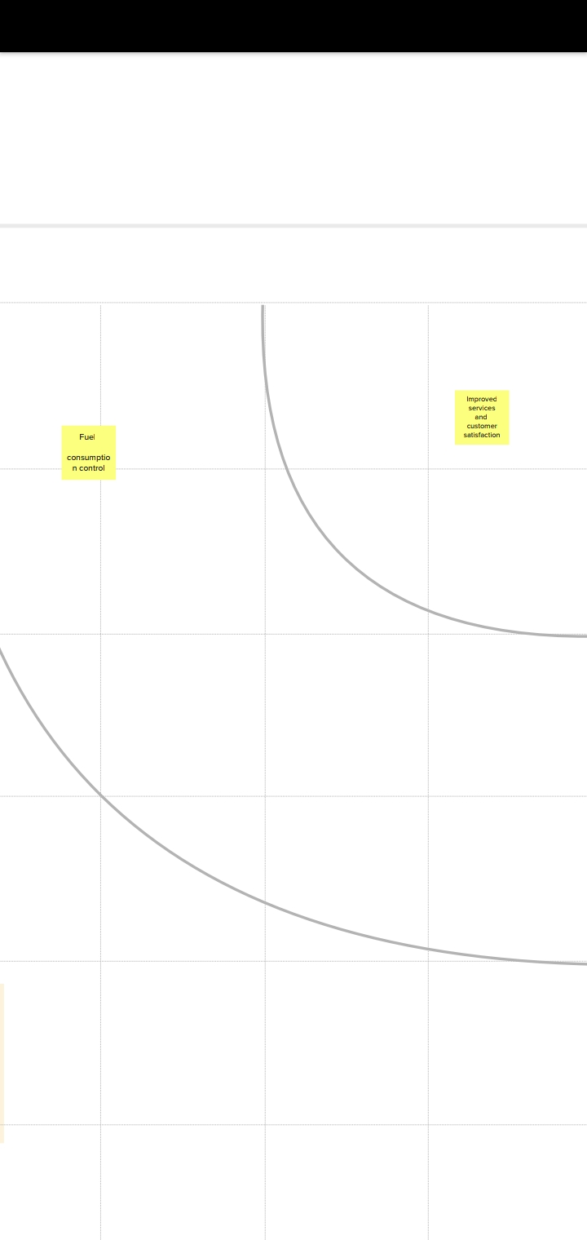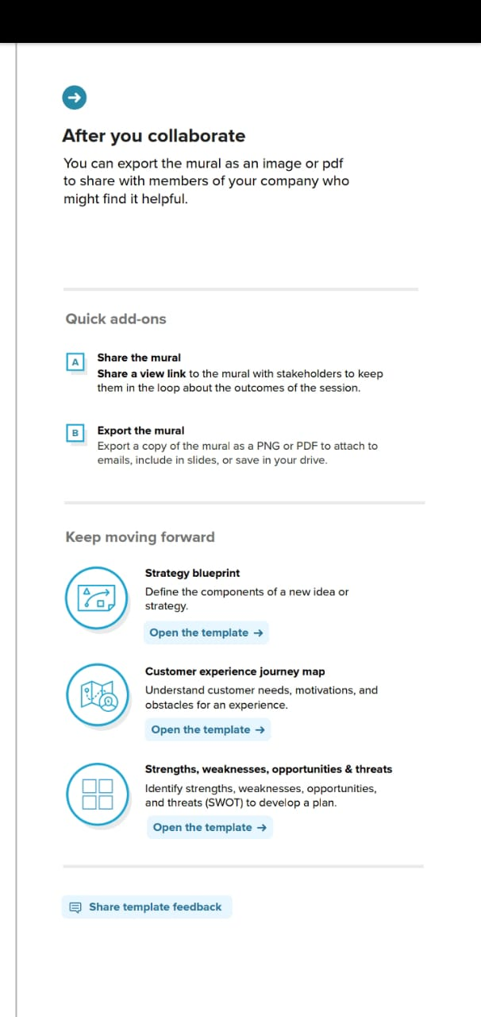

**3 RESULT**

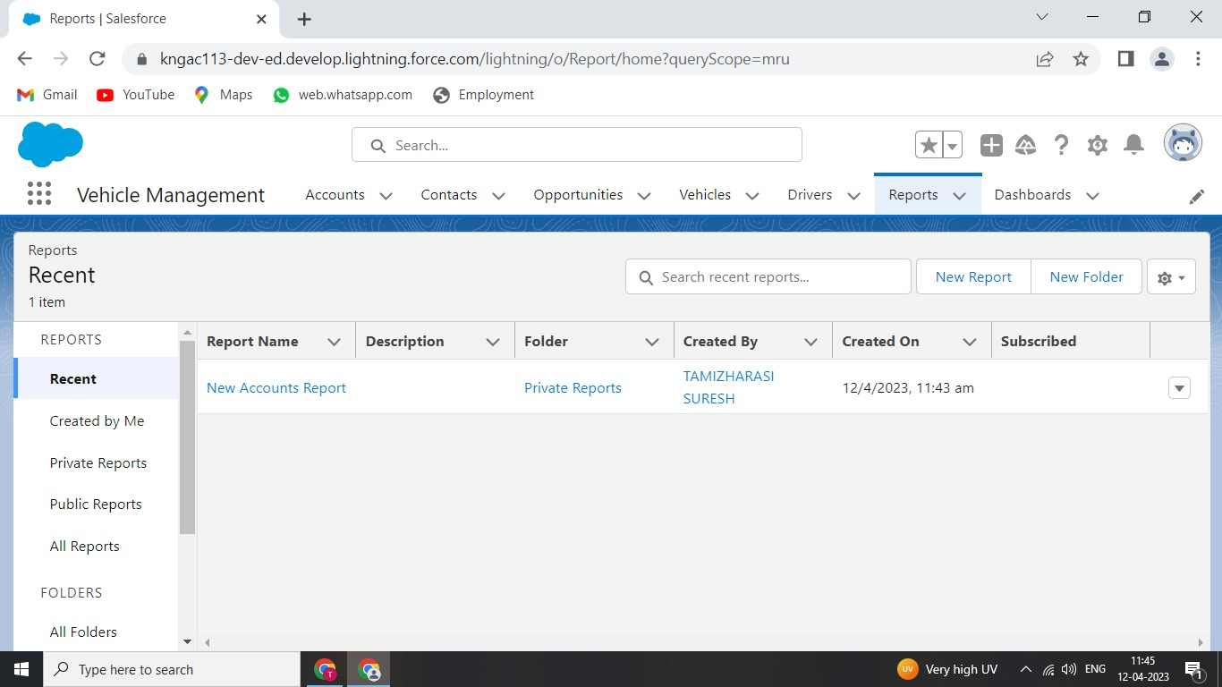

**4. ADVANTAGES AND DISADVANTAGES**

**Advantages**

Depending on the type of vehicle management system, it may include functionality to:

* Improve fleet safety and working conditions
* Improve the behavior and performance of drivers and beat unsafe driving
* Schedule shifts and work hours
* Leverage driver retention
* Track vehicles, assets or professional equipment (even trailers and containers)
* Schedule routine maintenance
* Manage fuel efficiency
* Keep track of malfunctions
* Track mileage and manage deductible expenses
* Produce individualized reports for all parties involved

**Disadvantages**

* Low frequency results in lower maximum data rate
* Although it is fast enough to allow multiple transmissions to increase reliability
* Tag usually request power from vehicle (active tag)
* Tag installation is not us convenient as that of a windshield-mountated tag.
* Moderate deficulty in duplicating tags.

**5. APPLICATIONS**

The Vehicle Management System allows providing a variety of services to the organization. This project helps the organization to reduce manual work. The real power of this project lies not in modules, but the creation of tighter and transparent relationships with users/ drivers/employees and delivering a high level of service and support, which in turn improves organization time and money.

**6. CONCLUSION**

Acting on the results and recommendations from the automated reports a vehicle management system has to offer in time, can help preserve and further improve reputation. At the same time, when a fleet is known for its efficiency and high-quality service, it will attract more new customers; and probably the best talent available in the market, to help staff the growing parts of the business.

**7. FUTURE SCOPE**

Vehicle management systems created by SCAND are designed to help our clients to keep track of the vehicles in real-time, plan, execute, and optimize their transportation processes through GPS and data collection.

**8. APPENDIX**

